[Alfred State College]

[Security Tools Project]
[CISSY 7033 - 2013]
Error: Reference source not found
Contents
Overview 3
Risk Identification 4
Risk Assessment Matrix 4
Vulnerability Assessment 5
Network Security Perimeter Compliance Section : 8
Security Layers 8
Screenshot Section of Configurations 8
Router Configuration: 9
Switch Configuration 11
Auditing Section 14
Security Onion 14
Web Server 15
TMG 16

Overview

Organization Name: | Alfred CISY Hospital
Employees: | 200
Services | AD DS, Web sites, File sharing, Email Server
Internal to External connection: | This network mainly focus on inside using. But it also provide outside internet connection by using Cisco router NAT.  internal network ip range: 192.168.1.X; 192.168.2.X; 192.168.3.X;  192.168.3.X will be the pool of internal users
External to internal Access | Our network doesn’t provide VPN access. (Optional proxy) Public user may access to Web services. External user does not allow to access internal services. Except the web server.
Internal Network Access: | All users can access our local computer by authenticated by AD. Internal users IP address signed be DHCP. Server IP signed manually..
Allowed Network Service and Protocol and Ports: | Web services, http, https. port 80 port 443  DNS - port 53  Samba services: firewall should allow  - UDP 137 UDP 138 TCP 139 TCP 445

Risk Identification
Assets | Data Classification | Impact to Functionality
Remote Connections | For Official Use | Critical
Web Server | Public | High
Mail Server | Internal | High
Print Server | Internal | Medium
Samba Server | Internal | Critical

Risk Assessment Matrix
Type of Data | Threats | Impact | Criticality | Comments
Medical Data | Data Confidentiality  Violation  Data Integrity Loss  Data Availability Loss | Financial Loss  Legal Implications  Loss of Data Integrity | Critical | This data is extremely sensitive and protected by all HIPPA laws, destruction, loss or misuse of this data could have serious legal and financial implications to our organization. Loss access of this data could lead to loss of life.
Personal Data | Data Confidentiality  Violation  Data Integrity Loss  Data Availability Loss | Financial Loss  Legal Implications  Loss of Data Integrity | High | Bulwarked by vigorous legislation. Incremented confidentiality, integrity and availability requisites, contravention of which is possible to result in licit implicative insinuations, defamation and consequent financial losses
Financial Data | Data Confidentiality  Violation  Data Integrity Loss  Data Availability Loss | Financial Loss  Legal Implications  Loss of Data Integrity | High | Highly sensitive financial data in relation to our organization, This must be secure in order to protect the integrity of our company and the financial stability of the company
Personnel Data | Data Confidentiality  Violation  Data Integrity Loss  Data Availability Loss | Financial Loss  Legal Implications  Loss of Data Integrity | Medium | Personnel data is sensitive and has increased confidentiality, integrity and availability requirements. Potential confidentiality violation could raise legal claim resulting financial losses and defamation.
General Information Data | Data Confidentiality  Violation  Data Integrity Loss  Data Availability Loss | Financial Loss  Legal Implications  Loss of Data Integrity | low | Loss of data integrity or availability could result in minor difficulties

Vulnerability Assessment
Threat | Possible Vulnerabilities
Software Attacks | Cookie poisoning – Identity Theft : manipulation of a stored cookie could  allow a hacker to gain access to the internal network using user credentials  Buffer overflow—Closure of business: exploiting the length of packets or form variables an attacker could effectively overwhelm a server causing failure  Cross-site scripting—Hijacking/Breach of Trust: if our web server/ site is not secure a hacker could inject malicious code , allowing them to gain access to confidential files  Database protocol vulnerabilities: Vulnerabilities in database protocols may allow unauthorized data access
Human Error | Employees unaware of security policies could possibly leak sensitive patient or company data without realizing. This is most commonly due to lack of training or lack of practice.
Hardware Failure | If the web server, file share server etc…. go down do does the hospital essentially. These services are vital which is why it is important to keep regular off-site backups of configurations, data etc..
Theft | A employee or third party could steal a hospital laptop for example that has a vpn connection pre-established allowing them to gain access to the network and pose future possible security issues

Topology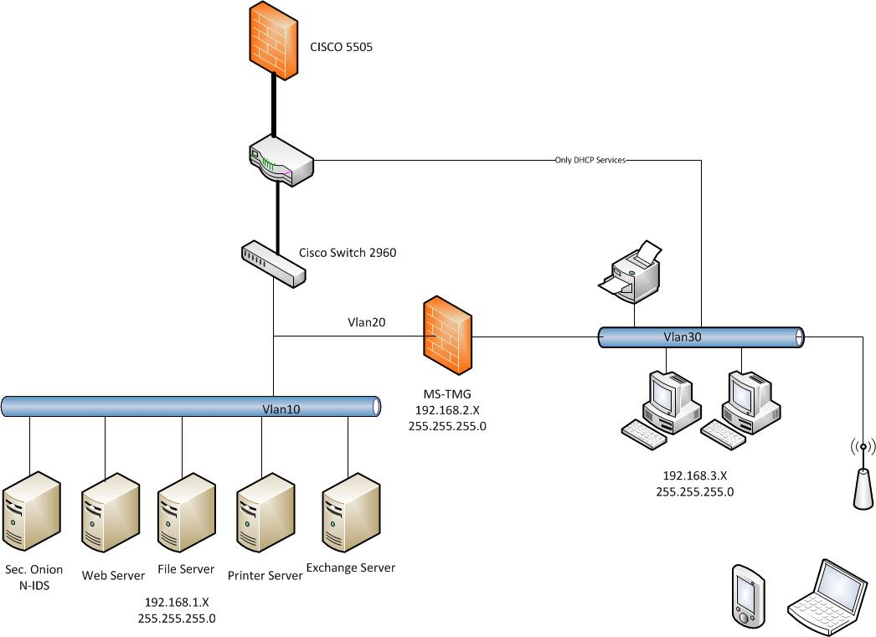

Network Security Perimeter Compliance Section :

Security Layers
Ring 1: Internet Edge: This is where we have our hardware firewalls. We have an ASA router firewall setup here.
Ring 2: Backbone Edge: Network Intrusion Detection Systems (NIDS) and Backbone Edge Firewalls. This is where we have Security Onion set up.
Ring 3: Asset Network Edge. We have a mail server, web server, file share server, and a print server set up. We have the servers set up on subnet 192.168.1.0, While TMG firewall and clients are set up on 192.168.2.0 and 192.168.3.0 respectively.
Ring 4: Host Based Security Ring. We have TMG firewall set up as the last line of defence between clients and the external network, and servers and the clients.

TMG uses a web proxy server to grant internal user’s network traffic. This also allows us to filter illicit web sties in order to deter employees from procrastination during working hours. The configuration on our networks router uses a static routing table, which means that the routing proccess was set up manually; because of this we can avoid the problem from dynamic routing protocol.
****I know that ISA 2004 also has a NIDS feature. The ISA was the part of the TMG. We don’t use it, but we can mention it if when we present.
How can TMG be in ring 3 and 4?
TMG was not affect the servers. because the TMG was local on 2.X subnet.
I am thinking that we suppose to get an AD to manage the asset of our network. because an AD can monitored the computer name on ? console. I cannot remember the ?. I can change the email server as a domain controller if you want. It has a pengsun.com domain when I was setting up the email server. We just simply add “AD” on the network diagram. thats it.

Screenshot Section of Configurations

Router Configuration:
Building configuration...

Current configuration : 2200 bytes
!
! Last configuration change at 03:05:53 UTC Wed Dec 11 2013
version 15.1
service timestamps debug datetime msec
no service timestamps log uptime
no service password-encryption
!
hostname BorderRouter
!
boot-start-marker
boot-end-marker
!
!
!
no aaa new-model
!
memory-size iomem 15
dot11 syslog
ip source-route
!
!
ip dhcp excluded-address 192.168.1.1
ip dhcp excluded-address 192.168.2.1
ip dhcp excluded-address 192.168.3.1
ip dhcp excluded-address 192.168.3.2
!
ip dhcp pool vlan10
network 192.168.1.0 255.255.255.0
default-router 192.168.1.1
dns-server 136.224.32.21
!
ip dhcp pool vlan20
network 192.168.2.0 255.255.255.0
default-router 192.168.2.1
dns-server 136.224.32.21
!
ip dhcp pool vlan30
network 192.168.3.0 255.255.255.0
dns-server 136.224.32.21
default-router 192.168.3.2
!
!
ip cef
no ipv6 cef
!
multilink bundle-name authenticated
!
crypto pki token default removal timeout 0
!
!
!
!
license udi pid CISCO1841 sn FTX1405YL98
!
redundancy
!
!
ip ssh version 1
!
!
!
!
!
!
!
interface FastEthernet0/0
no ip address
ip nat inside
no ip virtual-reassembly in
duplex auto
speed auto
!
interface FastEthernet0/0.1
encapsulation dot1Q 10
ip address 192.168.1.1 255.255.255.0
ip nat inside
no ip virtual-reassembly in
!
interface FastEthernet0/0.2
encapsulation dot1Q 20
ip address 192.168.2.1 255.255.255.0
ip nat inside
no ip virtual-reassembly in
!
interface FastEthernet0/0.3
encapsulation dot1Q 30
ip address 192.168.3.1 255.255.255.0
!
interface FastEthernet0/1
ip address dhcp
ip nat outside
ip virtual-reassembly in
duplex auto
speed auto
!
interface Serial0/0/0
no ip address
shutdown
no fair-queue
clock rate 125000
!
interface Serial0/0/1
no ip address
shutdown
clock rate 125000
!
!
router eigrp 100
network 192.168.1.0
network 192.168.2.0
network 192.168.3.0
!
ip forward-protocol nd
no ip http server
no ip http secure-server
!
!
ip nat inside source list 1 interface FastEthernet0/1 overload
ip route 0.0.0.0 0.0.0.0 136.224.133.1 254
ip route 192.168.1.0 255.255.255.0 FastEthernet0/0.1
ip route 192.168.2.0 255.255.255.0 FastEthernet0/0.2
!
access-list 1 permit any
!
!
!
!
!
!
control-plane
!
!
!
line con 0
line aux 0
line vty 0 4
login
transport input all
!
scheduler allocate 20000 1000
End

Switch Configuration

Building configuration...

Current configuration : 1910 bytes
!
version 12.2
no service pad
service timestamps debug datetime msec
service timestamps log datetime msec
no service password-encryption
!
hostname Switch
!
boot-start-marker
boot-end-marker
!
!
!
!
no aaa new-model
system mtu routing 1500
!
!
!
!
!
!
!
!
spanning-tree mode pvst
spanning-tree extend system-id
!
vlan internal allocation policy ascending
!
!
!
interface FastEthernet0/1
switchport mode trunk
!
interface FastEthernet0/2
switchport access vlan 10
switchport mode access
!
interface FastEthernet0/3
switchport access vlan 10
switchport mode access
!
interface FastEthernet0/4
switchport access vlan 10
switchport mode access
!
interface FastEthernet0/5
switchport access vlan 20
switchport mode access
!
interface FastEthernet0/6
switchport access vlan 20
switchport mode access
!
interface FastEthernet0/7
switchport access vlan 20
switchport mode access
!
interface FastEthernet0/8
switchport access vlan 20
switchport mode access
!
interface FastEthernet0/9
!
interface FastEthernet0/10
!
interface FastEthernet0/11
!
interface FastEthernet0/12
!
interface FastEthernet0/13
switchport access vlan 30
switchport mode access
!
interface FastEthernet0/14
switchport access vlan 30
switchport mode access
!
interface FastEthernet0/15
switchport access vlan 30
switchport mode access
!
interface FastEthernet0/16
switchport access vlan 30
switchport mode access
!
interface FastEthernet0/17
switchport access vlan 40
switchport mode access
!
interface FastEthernet0/18
switchport access vlan 40
switchport mode access
!
interface FastEthernet0/19
!
interface FastEthernet0/20
!
interface FastEthernet0/21
!
interface FastEthernet0/22
!
interface FastEthernet0/23
!
interface FastEthernet0/24
!
interface GigabitEthernet0/1
!
interface GigabitEthernet0/2
!
interface Vlan1
no ip address
shutdown
!
ip http server
ip http secure-server
!
line con 0
line vty 5 15
!
end

Auditing Section

Security Onion
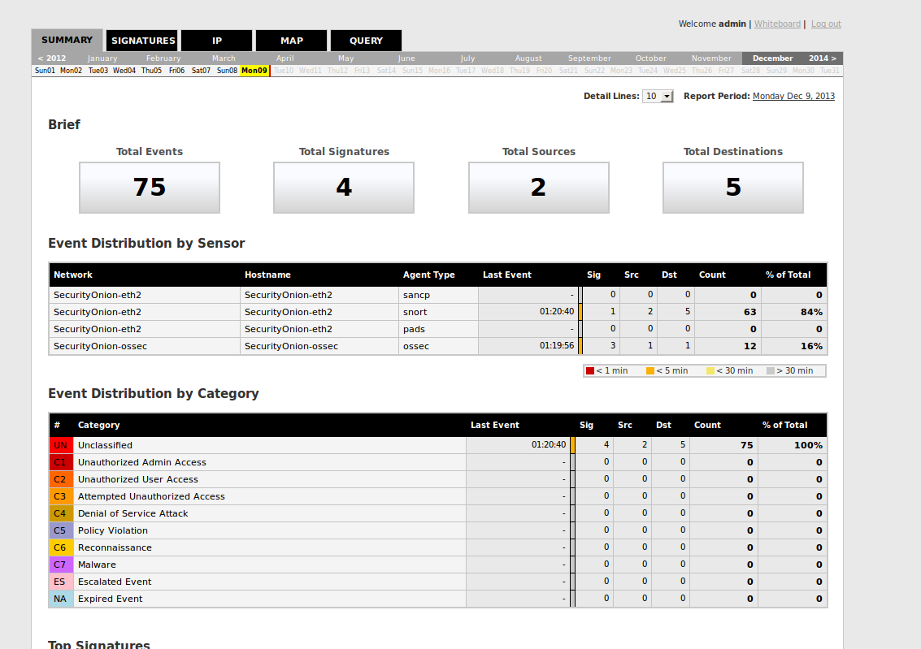
Interesting Traffic Detected

Web Server
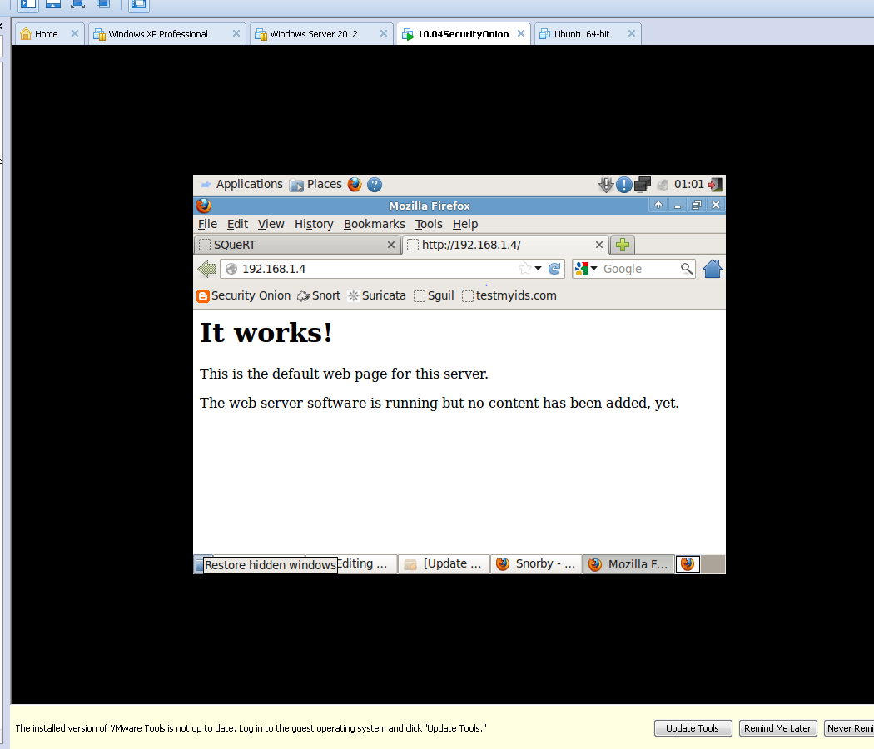

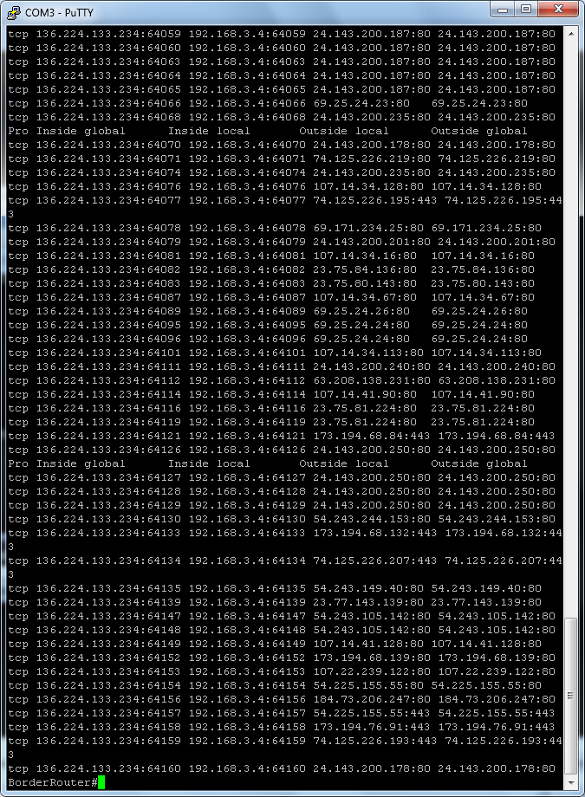

TMG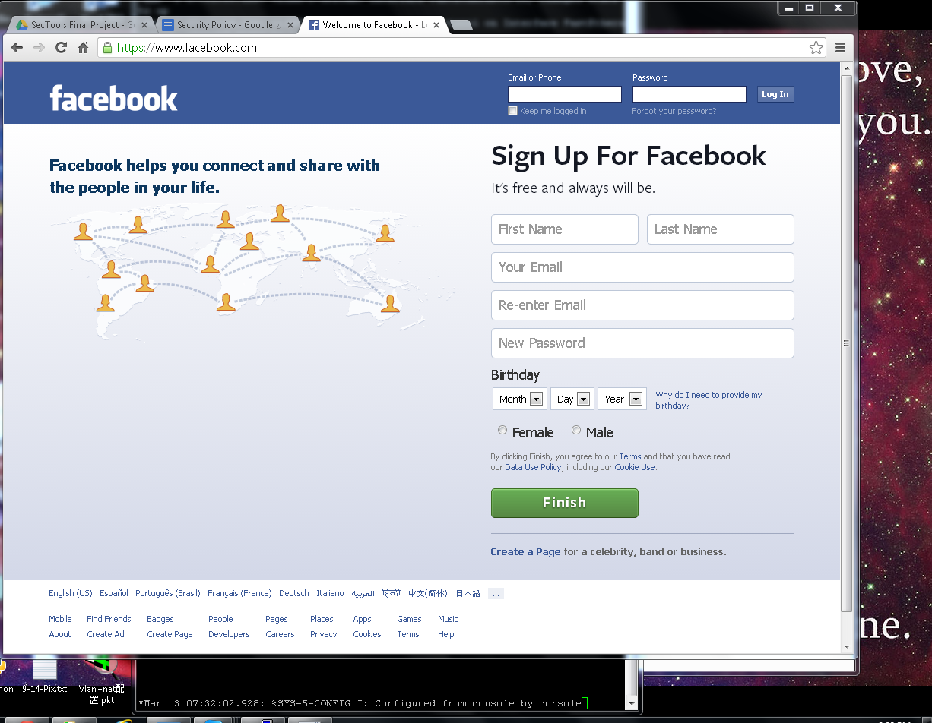
TMG Illicit Site Access
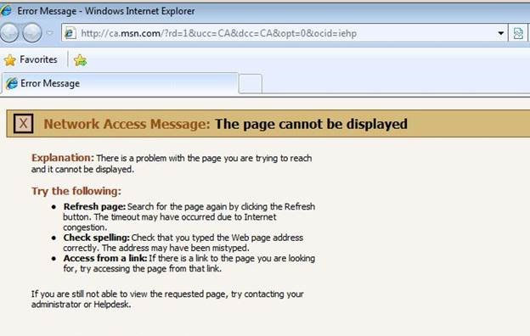
TMG Illicit Site Block
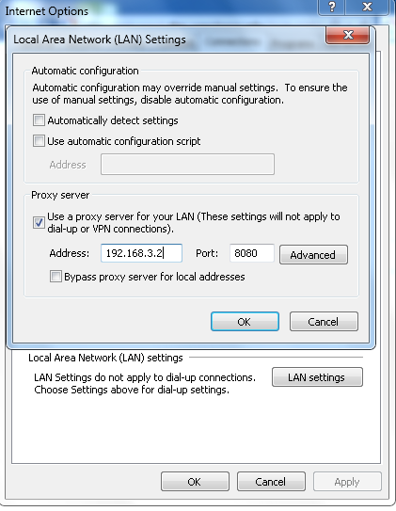
Configuring IE Proxy Server

